Appendix C: IEEE 830 Template
Software Requirements Specification
for
Public Transport Tickets System

Version 2.0
Prepared by Jakub Boczkowski
Lodz University of Technology - WEEIA IFE
03.03.2026

Table of Contents
«Table of Contents»
Revision History
Name | Date | Reason for Changes | Version
Jakub Boczkowski | 03.03.2026 | Initial version | 1.0
Jakub Boczkowski | 10.03.2026 | Added UML diagram | 2.0
«Page break»
1. Introduction
1.1. Purpose
The purpose of this product is to provide users with mobile application which will decrease the time they spend on purchasing public transport tickets. The current version is 1.0. It aims to enable them to purchase tickets by clicking only one button while entering chosen way of transport and then clicking it again while leaving. The project shall automatically get users location and find appropriate stop.
«Identify the product whose software requirements and design are specified in this document, including the revision or release number. Describe the scope of the product that is covered by this specification.»
1.2. Document Conventions
The document follows a standard typographical convention. Detailed requirements are highlighted when there is a special significance.
1.3. Intended Audience and Reading Suggestions
This document is intended for specified audience, including Developers, Users, Testers and Marketing Staff.
They are all to inform other readers of the steps taken for further development. There is a special sequence for reading the document for each members of the audience mentioned above:
- Developers:
- Users:
- Testers:
- Marketing Staff:
1.4. Product Scope
«Provide a short description of the software being specified and its purpose, including relevant benefits, objectives, and goals. Relate the software to corporate goals or business strategies when applicable.»
The Public Transport Tickets System is a mobile application designed to completely automate and simplify the process of purchasing public transport tickets. Its primary goal is to eliminate the need for physical ticket machines and complex manual ticket selection in existing apps. By utilizing GPS technology, the software will allow users to seamlessly check in and check out of a vehicle with a single button press, while the system calculates the correct fare based on the traveled distance or time. This aligns with the modern objective of making public commuting faster, more accessible, and user-friendly.

1.5. References
«List any other documents or Web addresses to which this document refers or was based on. These may include user interface style guides, contracts, standards, system requirements specifications, use case documents, or a vision and scope document. Provide enough information so that the reader could access a copy of each reference, including title, author, version number, date, and source or location. Include the assignment document in the references.»
- IEEE Std 830-1998, IEEE Recommended Practice for Software Requirements Specifications.
- "Lab 1: Requirements Analysis" presentation, dr inż. Abdulla Juwaied, Lodz University of Technology - IFE

2. Overall Description
2.1. Product Perspective
«Describe the context and origin of the product being specified in this specification. For example, state whether this product is a follow-on member of a product family, a replacement for certain existing systems, or a new, self-contained product.»
The Public Transport Tickets System is a new, self-contained mobile application. It is not a direct follow-on to an existing software family, but rather an innovative alternative to traditional, manual ticket-purchasing apps currently used in public transport.
2.2. Product Features
«Summarize the major features the product must perform or must let the user perform. Details will be provided in Section 3, so only a bullet list is needed here. Organize the features to make them understandable to any reader of the specification. A picture of the major groups of related requirements and how they relate, such as a top level data flow diagram or object class diagram, is often effective.»
«Thing 1»
«More things as required»
- One-click check-in and check-out process.
- Automatic user geolocation to identify the starting and ending stops.
- Automated fare calculation based on the registered route.
- Digital ticket generation and display for inspection purposes

2.3. User Classes and Characteristics
«Identify the various user classes (intended target for the product) that you anticipate will use this product. User classes may be differentiated based on frequency of use, subset of product functions used, technical expertise, security or privilege levels, educational level, or experience. Describe the pertinent characteristics of each user class. Certain requirements may pertain only to certain user classes. Distinguish the most important user classes for this product from those who are less important to satisfy.»
Passengers (Primary Users): Everyday commuters and tourists. They require a highly intuitive, fast, and simple interface without the need for high technical expertise. This is the most important user class.
Ticket Inspectors: Transport authority staff who will need a reliable way to visually or digitally verify the generated active tickets.

2.4. Operating Environment
«Describe the environment in which the software will operate, including the hardware platform, operating system and versions, and any other software components or applications with which it must peacefully coexist.»

The software will operate as a mobile application on modern smartphones running Android and iOS operating systems. It requires continuous access to the device's GPS module and an active internet connection to communicate with the main server.

2.5. Design and Implementation Constraints
«Describe any items or issues that will limit the options available to the developers. These might include: corporate or regulatory policies; hardware limitations (timing requirements, memory requirements); interfaces to other applications; specific technologies, tools, and databases to be used; parallel operations; language requirements; communications protocols; security considerations; design conventions or programming standards (for example, if the customer’s organization will be responsible for maintaining the delivered software).»

At this stage, the main constraint is the reliance on the accuracy of the mobile device's GPS signal, which can be limited inside specific vehicles (e.g., underground trams). Additionally, the system must not drain the smartphone's battery excessively while tracking the location during the ride. We are not specifying backend databases or programming languages yet, to avoid implementation bias.

2.6. User Documentation
«List the user documentation components (such as user manuals, on-line help, and tutorials) that will be delivered along with the software. Identify any known user documentation delivery formats or standards.»

The application will include a short, interactive "first-launch" tutorial showing the one-click process. A built-in "Help & FAQ" section will also be provided.

2.7. Assumptions and Dependencies
«List any assumed factors (as opposed to known facts) that could affect the requirements stated in the specification. These could include third-party or commercial components that you plan to use, issues around the development or operating environment, or constraints. The project could be affected if these assumptions are incorrect, are not shared, or change. Also identify any dependencies the project has on external factors, such as software components that you intend to reuse from another project, unless they are already documented elsewhere (for example, in the vision and scope document or the project plan).»
It is assumed that the user will grant the application permission to access their location services. The project depends on external map and geolocation APIs (e.g., Google Maps API or equivalent) to accurately match coordinates with public transport stops.
3. System Features
«The purpose here is to give a brief introduction to the system features, so that §4 has something to reference. Then, the full explanation of the system features is given in §5, likely referencing §4. The numbering in §3 and §5 should match.»
3.1. «Feature Name» One-Click Check-In and Check-Out
«Brief description of the feature, generally 1-3 sentences»
This feature allows users to initiate their journey by clicking a single button when entering the transport vehicle. The user completes the journey by clicking the same button upon exiting. This significantly decreases the time users spend purchasing tickets.
3.«N». «Additional feature blocks as needed»
3.2. Automatic Stop Identification
The system automatically retrieves the user's current geographical location. Using this data, it finds the appropriate public transport stop where the user is beginning or ending their journey.
3.3. Automated Fare Calculation
Based on the identified check-in and check-out stops, the application automatically calculates the correct fare for the journey. This eliminates the need for manual ticket selection, zones, or time limits by the user.
3.4. Digital Ticket Display
Upon a successful check-in, the system generates an active digital ticket. This screen acts as proof of purchase and can be displayed to ticket inspectors during the ride.

4. External Interface Requirements
4.1. User Interfaces Overview
«Describe the high level functionality of the system from the user’s perspective. Explain how the user should be able to use your system to complete all the expected features and the feedback information that will be displayed for the user (for each screen the user will see). For example, specify whether it is GUI or text based interface and how at high level it would work. Discuss at high level how user will interact with the game such as clicking buttons, typing in some selection character, etc.»
«Describe the minimum requirements for the interface. This may include some sample screen images whether for text or GUI approach, any GUI standards or product family style guides that are to be followed, screen layout constraints, for GUI standard buttons and functions (e.g., help) that must appear on every screen, keyboard shortcuts, error message display standards, and so on»
4.2. Hardware Interfaces
«Describe the logical and physical characteristics of each interface between the software product and the hardware components of the system. This may include the supported device types, the nature of the data and control interactions between the software and the hardware, and communication protocols to be used.»
4.3. Software Interfaces
«Describe the connections between this product and other specific software components (name and version), including databases, interpreters, operating systems, tools, libraries, and integrated commercial components. Identify the data items or messages coming into the system and going out and describe the purpose of each. Describe the services needed and the nature of communications. Identify data that will be shared across software components. If the data sharing mechanism must be implemented in a specific way (for example, use of a global data area in a multitasking operating system), specify this as an implementation constraint.»
5. System Features/Modules
«This template illustrates organizing the functional requirements for the product by system features, the major services provided by the product.»
5.1. «System Feature Name»
5.1.1 Description and Priority
«Provide a short description of the feature. Give its priority, too.»
5.1.2 Stimulus/Response Sequences
«”Stimulus” or “Condition”»: «Describe the stimulus or condition»
Response: «Describe the response»
«Additional Stimulus/Response pairs as needed»
5.1.3 Functional Requirements
«Itemize the detailed functional requirements associated with this feature. These are the software capabilities that must be present in order for the user to carry out the services provided by the feature. Include how the product should respond to anticipated error conditions or invalid inputs. Requirements should be concise, complete, unambiguous, verifiable, and necessary. Each requirement should be uniquely identified with a sequence number or a meaningful tag of some kind.»
REQ-1.1: «Some sentence goes here, in “shall” form, usually something like this: “Upon <some event or condition>, the <system, or the name of a module> shall <perform some action>.” Note that the entire requirement must be stated in the requirements area. Everything else is just a lead-up to this. There should be one such entry per S/R pair.»
REQ-1.«N»: «Additional S/R-related requirements as needed.»
REQ-1.«N»: «List any additional requirements needed in “Shall” form, but not necessarily in “Upon/Shall” form.»
REQ-1.«N»: «Additional requirements as needed.»
5.«N». «Additional feature blocks»
6. Nonfunctional Requirements
6.1. Performance
NF-1.1: «Any performance-related issue»
NF-1.«N»: «Any performance-related issue»
6.2. Security
NF-2.1: «Any security-related issue»
NF-2.«N»: «Any security-related issue»
6.«N». «Any additional “nonfunctional” blocks»

7. System use diagram
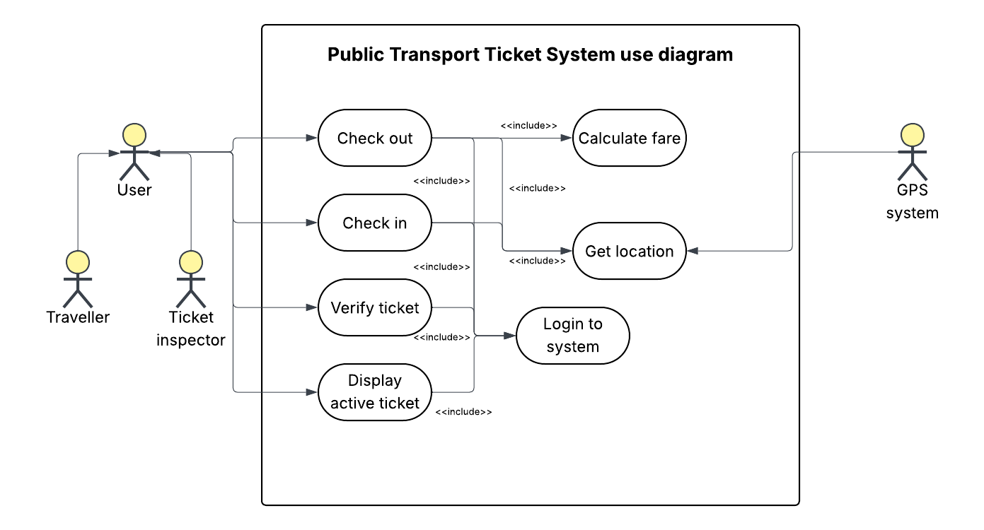
A diagram above shows how the Public Transport Ticket System works. User which can be Traveller or Ticket inspector is able to check out, check in, verify ticket or display active ticket. Those functions include logging to the system and allowing locations services so the GPS system can get the location of user. Checking out includes calculating a fare.

